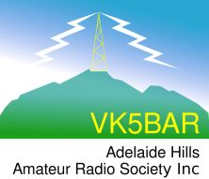

VK5 National & Conservation Parks Award.

1. Aim

The aim of this Award is to encourage portable operation by amateur radio operators from within South Australia’s 21 National Parks (NP), and 262 Conservation Parks (CP), which are controlled by the Department of Environment, Water and Natural Resources (DEWNR).

2. Eligibility

The Award is open to the following:-

(a) Activators

An individual amateur radio operator, or a group of amateur radio operators, who activate portable from within a South Australian National Park and / or a South Australian Conservation Park.

(b) Hunters

An individual who makes contact with an Activator/s operating portable from within a South Australian National Park and / or a South Australian Conservation Park.

(c) Listeners

An individual who logs the activities of an Activator/s operating portable from within a South Australian National Park and / or a South Australian Conservation Park.
3. Valid Contacts

(a) To qualify for the Award a radio amateur operator / short wave listener must:

- Accrue a specified number of points by operating portable from South Australia’s National Parks and / or Conservation Parks;

or

- Accrue a specified number of points by making contact with an amateur/s operating portable from South Australia’s National Parks and / or Conservation Parks;

or

- Accrue a specified number of points as a short wave listener (SWL), by logging portable activations from South Australia’s National Parks and / or Conservation Parks.

(b) Contacts via Repeaters, IRLP or Echolink are not permitted.

(c) Mobile operation (defined as in or on a vehicle) from within a South Australian National Park / and or Conservation park is not permitted. The award is designed to encourage portable operation, and not mobile and/or stationary mobile operation.

(d) Contacts after 14th^{st} April 2013 are valid for the Award.

(e) Each South Australian National Park shall qualify with 2 points.

(f) Each South Australian Conservation Park shall qualify with 1 point.

(g) Only one QSO is required for a park to be considered to have been activated and qualify for points.

(h) A park may be activated as often as is desired by an individual activator. However, activators can only claim points from a particular park once in every calendar year.

(i) Hunters may only claim points for a particular park, once in every calendar year.

(j) For Hunters, only one QSO with a given park on any one day (defined as 00:00 UTC to 23:59 UTC) will count for points. e.g. 2 different activators work from Belair National Park under different calls on the same day. Only one QSO from Belair NP will count for Hunter points.

(k) The following types of South Australian parks under the control of DEWNR, do not qualify for this Award:-

  - Game Reserves (GR)
  - Recreation Parks (RP)
  - Regional Reserves (RR)
  - Wilderness Protection Area (WPA)
  - Conservation Reserves (CR)
  - Marine Parks (MP)

4. Award levels (Australian amateur radio operators / Australian SWL’s).

For Australian amateur radio operators / Australian short wave listeners, the Award will be issued in 5 levels as follows:

(1) Bronze

- A total of 10 points.

(ii) Silver

- A total of 20 points.

(iii) Gold

- A total of 35 points.

(1v) Platinum

- A total of 50 points.

(v) Diamond

- A total of 70 points (including all 21 South Australian National Parks).

5. Award levels (Overseas amateur operators/Overseas SWL’s).

For Overseas amateur radio operators / overseas short wave listeners, the Award will be issued in 5 levels as follows:

(1) Bronze

- A total of 5 points.

(ii) Silver

- A total of 10 points.

(iii) Gold

- A total of 15 points.

(iv) Platinum

- A total of 20 points.

(v) Diamond

- A total of 50 points (including all 21 South Australian National Parks).

6. Endorsements.

(a) Special endorsements will be issued for the following:-

(1) QRP operation.

(2) CW only.

(3) single band operation.

(4) VHF/UHF only (no repeaters)

Other endorsements will be considered.

7. Certificates / plaque for Activators / Hunters / SWL’s

(a) Separate individual certificates will be issued for Bronze, Silver, Gold, Platinum & Diamond levels. For Activators / Hunters / SWL’s. The certificates at each level will feature different photographs.

(b) Achieving Diamond level requires a significant amount of dedication and effort. Because of this, an optional glass etched trophy will be awarded for Diamond level, along with the Diamond level certificate.

These glass etched trophies measure about 9 cm (W) & 12 cm (H), and weigh about 670 grams, and will be individually engraved with the recipient’s call sign and name.

(c) Once you have achieved the basic “Bronze” level of the Award, you can continue to build up your total points. Additional certificates will be awarded once additional points have been attained and specific Award levels reached.

8. Park to Park certificate

(a) Separate certificates will be issued to those Activators operating portable in a park who make contact with another Activator operating portable in a park.

(b) Points from your activation are combined with the points from the other activation. e.g. you operate from a National Park (worth 2 points) and make contact with someone in a Conservation Park (worth 1 point). Add your 2 points for the NP with the 1 point for the CP. A total of 3 points.

(c) The park to park certificates will be issued in 5 levels as follows:

(i) Bronze

- A total of 10 points.

(ii) Silver

- A total of 15 points.

(iii) Gold

- A total of 20 points.

(1v) Platinum

- A total of 40 points.

(v) Diamond

- A total of 50 points (including all 21 South Australian National Parks).

9. Unique Parks certificates

(a) Certificates are issued to Activators, Hunters, & SWL’s for operating from / making contact with / logging unique / different parks.

(b) Unique parks are a tally of the number of different parks in an Activator’s, Hunter’s or SWL’s log. e.g. Cleland Conservation Park is one unique park, Peebinga Conservation Park is another unique park, Coorong National Park is another unique park, etc.

(c) The Unique certificates for National Parks will be issued in 5 levels as follows:

(i) Bronze

- 5 unique/different National Parks.

(ii) Silver

- 7 unique/different National Parks.

(iii) Gold

- 10 unique/different National Parks.

(iv) Platinum

- 15 unique/different National Parks.

(v) Diamond

- All 21 National Parks.

(d) The Unique certificates for Conservation Parks will be issued in 5 levels as follows:

(i) Bronze

- 25 unique/different Conservation Parks.

(ii) Silver

- 50 unique/different Conservation Parks.

(iii) Gold

- 100 unique/different Conservation Parks.

(iv) Platinum

- 150 unique/different Conservation Parks.

(v) Diamond

- All 262 Conservation Parks.

10. Submission for Awards.

Application forms can be found either on the Adelaide Hills Amateur Radio Society website, or the VK5 Yahoo Users Group. Alternatively you can send an extract of your log. This can be computer generated, an ADIF file, handwritten, excel spreadsheet.

Applications for this Award should be forwarded to:-

The Awards Manager,
Adelaide Hills Amateur Radio Society Inc,
P.O. Box 401,
Blackwood,
S.A.
5051.

Applications will include the following:-

- Application form which must include the following:

  - Callsign of station worked/heard
  - Name of operator worked
  - Date
  - Time
  - Frequency
  - Mode
  - Your power output
  - Name of National Park / Conservation Park.

- QSL cards are not required.

- For all Bronze, Silver, Gold, Platinum & Diamond certificates:

- AUSTRALIAN operators/SWL’s
  - AUD $5.00 or 2 valid International Reply Coupons (IRC’s).

- OVERSEAS operators/SWL’s.
  - AUD $10.00 or 3 valid International Reply Coupons (IRC’s).

- For optional Diamond Award trophy:

- AUSTRALIAN operators/SWL’s
  - AUD $60.00 or 18 valid International Reply Coupons (IRC’s)

- OVERSEAS operators/SWL’s
  - AUD $75.00 or 22 valid International Reply Coupons (IRC’s)

Or alternatively, money for the cost of the Award certificates or trophy can be placed into the Adelaide Hills Amateur Radio Society account (please include a notation that the money is for the VK5 Nat. & Cons. Parks Award):-

Bank SA:

Name: AHARS
BSB: 105 186
Account no: 036 248 940

The Awards Manager reserves the right to check log validity.

11. Further Reference.

Further information regarding the Award can be found at:-

(a) Adelaide Hills Amateur Radio Society (AHARS) website

http://ahars.com.au

(b) VK5 National & Conservation Parks Award Yahoo group.

http://au.groups.yahoo.com/group/sanpcpa

Further details on South Australia’s National Parks and Conservation Parks can be located at the Department of Environment Water and Natural Resources (DEWNR) website at:-

http://www.environment.sa.gov.au/Home

12. Annexures

(a) Appendix A
- List of South Australia’s National Parks & Conservation Parks
(b) Appendix B
- South Australia National Parks map
(c) Appendix C
- Adelaide & Adelaide Hills Map
(d) Appendix D
- Eyre Peninsula map
(e) Appendix E
- Fleurieu Peninsula map
(f) Appendix F
- Flinders Ranges & Outback Map
(g) Appendix G
- Kangaroo Island map
(h) Appendix H
- Limestone Coast map
(i) Appendix I
- Riverland & Murraylands map
(j) Appendix J
- Yorke Peninsula & Clare Valley map

Appendix A

List of South Australia’s National Parks and Conservation Parks.

Park Name | Reserve Type | Region | District
Belair | NP | Adelaide | Southern Lofty
Canunda | NP | South East | Lower South East
Coffin Bay | NP | West | Eyre
Coongie Lakes | NP | Outback | North East Deserts
Coorong | NP | South East | Coorong
Flinders Chase | NP | Kangaroo Island | Kangaroo Island
Flinders Ranges | NP | Outback | Northern Flinders
Gawler Ranges | NP | West | Eyre
Great Australian Bight Marine | NP | West | Western
Innes | NP | Northern and Yorke | Yorke
Lake Eyre | NP | Outback | Central Deserts
Lake Gairdner | NP | West | Western
Lake Torrens | NP | Outback | Northern Flinders
Lincoln | NP | West | Eyre
Mount Remarkable | NP | Northern and Yorke | Southern Flinders
Murray River | NP | Murraylands | Riverland
Naracoorte Caves | NP | South East | Upper South East
Nullarbor | NP | West | Western
Onkaparinga River | NP | Adelaide | Southern Lofty
Vulkathunha - Gammon Ranges | NP | Outback | Northern Flinders
Witjira | NP | Outback | Central Deserts
Aberdour | CP | South East | Upper South East
Acraman Creek | CP | West | Western
Aldinga Scrub | CP | Adelaide | Southern Lofty
Althorpe Islands | CP | Northern and Yorke | Yorke
Angove | CP | Adelaide | Northern Lofty
Avoid Bay Islands | CP | West | Eyre
Baird Bay Islands | CP | West | Western
Bakara | CP | Murraylands | Mallee
Bangham | CP | South East | Upper South East
Barwell | CP | West | Eyre
Bascombe Well | CP | West | Eyre
Baudin | CP | Kangaroo Island | Kangaroo Island
Baudin Rocks | CP | South East | Lower South East
Beachport | CP | South East | Lower South East
Beatrice Islet | CP | Kangaroo Island | Kangaroo Island
Belt Hill | CP | South East | Lower South East
Beyeria | CP | Kangaroo Island | Kangaroo Island
Big Heath | CP | South East | Upper South East
Billiatt | CP | Murraylands | Mallee
Bimbowrie | CP | Northern and Yorke | Mid North
Bird Islands | CP | Northern and Yorke | Yorke
Black Hill | CP | Adelaide | Northern Lofty
Black Rock | CP | Northern and Yorke | Southern Flinders
Boondina | CP | West | Western
Brookfield | CP | Murraylands | Riverland
Busby Islet | CP | Kangaroo Island | Kangaroo Island
Butcher Gap | CP | South East | Lower South East
Calectasia | CP | South East | Lower South East
Calpatanna Waterhole | CP | West | Western
Cap Island | CP | West | Eyre
Cape Blanche | CP | West | Western
Cape Gantheaume | CP | Kangaroo Island | Kangaroo Island
Cape Willoughby | CP | Kangaroo Island | Kangaroo Island
Caralue Bluff | CP | West | Eyre
Carappee Hill | CP | West | Eyre
Carcuma | CP | Murraylands | Mallee
Caroona Creek | CP | Northern and Yorke | Mid North
Carpenter Rocks | CP | South East | Lower South East
Carribie | CP | Northern and Yorke | Yorke
Chadinga | CP | West | Western
Charleston | CP | Adelaide | Northern Lofty
Cleland | CP | Adelaide | Southern Lofty
Clements Gap | CP | Northern and Yorke | Southern Flinders
Clinton | CP | Northern and Yorke | Yorke
Cocata | CP | West | Eyre
Cooltong | CP | Murraylands | Riverland
Corrobinnie Hill | CP | West | Western
Cox Scrub | CP | Adelaide | Fleurieu
Cromer | CP | Adelaide | Northern Lofty
Cudlee Creek | CP | Adelaide | Northern Lofty
Custon | CP | South East | Upper South East
Danggali | CP | Murraylands | Riverland
Darke Range | CP | West | Eyre
Deep Creek | CP | Adelaide | Fleurieu
Desert Camp | CP | South East | Upper South East
Dingley Dell | CP | South East | Lower South East
Douglas Point | CP | South East | Lower South East
Dudley | CP | Kangaroo Island | Kangaroo Island
Eba Island | CP | West | Western
Ediacara | CP | Outback | Northern Flinders
Elliot Price | CP | Outback | Central Deserts
Eric Bonython | CP | Adelaide | Fleurieu
Eurilla | CP | Adelaide | Southern Lofty
Ewens Ponds | CP | South East | Lower South East
Fairview | CP | South East | Upper South East
Ferguson | CP | Adelaide | Northern Lofty
Ferries - McDonald | CP | Murraylands | Mallee
Finniss | CP | Adelaide | Fleurieu
Fort Glanville | CP | Adelaide | Northern Lofty
Fowlers Bay | CP | West | Western
Franklin Harbor | CP | West | Eyre
Furner | CP | South East | Lower South East
Gambier Islands | CP | West | Eyre
Gawler Ranges | CP | West | Western
Geegeela | CP | South East | Upper South East
Giles | CP | Adelaide | Northern Lofty
Glen Roy | CP | South East | Lower South East
Goose Island | CP | Northern and Yorke | Yorke
Gower | CP | South East | Lower South East
Grass Tree | CP | South East | Upper South East
Greenly Island | CP | West | Eyre
Guichen Bay | CP | South East | Lower South East
Gum Lagoon | CP | South East | Upper South East
Gum Tree Gully | CP | Adelaide | Fleurieu
Hacks Lagoon | CP | South East | Upper South East
Hale | CP | Adelaide | Northern Lofty
Hallett Cove | CP | Adelaide | Southern Lofty
Hanson Scrub | CP | South East | Upper South East
Heggaton | CP | West | Eyre
Hesperilla | CP | Adelaide | Fleurieu
Hincks | CP | West | Eyre
Hogwash Bend | CP | Murraylands | Riverland
Hopkins Creek | CP | Northern and Yorke | Mid North
Horsnell Gully | CP | Adelaide | Northern Lofty
Ironstone Hill | CP | West | Eyre
Jip Jip | CP | South East | Upper South East
Kaiserstuhl | CP | Adelaide | Northern Lofty
Kapunda Island | CP | Murraylands | Riverland
Karte | CP | Murraylands | Mallee
Kathai | CP | West | Eyre
Kellidie Bay | CP | West | Eyre
Kelly Hill | CP | Kangaroo Island | Kangaroo Island
Kelvin Powrie | CP | South East | Upper South East
Kenneth Stirling | CP | Adelaide | Northern Lofty
Kulliparu | CP | West | Eyre
Kungari | CP | South East | Lower South East
Kyeema | CP | Adelaide | Fleurieu
Lake Frome | CP | South East | Lower South East
Lake Gilles | CP | West | Western
Lake Hawdon South | CP | South East | Lower South East
Lake Newland | CP | West | Western
Lake St Clair | CP | South East | Lower South East
Lashmar | CP | Kangaroo Island | Kangaroo Island
Lathami | CP | Kangaroo Island | Kangaroo Island
Laura Bay | CP | West | Western
Lesueur | CP | Kangaroo Island | Kangaroo Island
Leven Beach | CP | Northern and Yorke | Yorke
Lincoln | CP | West | Eyre
Lipson Island | CP | West | Eyre
Little Dip | CP | South East | Lower South East
Lowan | CP | Murraylands | Mallee
Lower Glenelg River | CP | South East | Lower South East
Maize Island Lagoon | CP | Murraylands | Riverland
Malgra | CP | West | Eyre
Mamungari | CP | West | Western
Marino | CP | Adelaide | Southern Lofty
Mark Oliphant | CP | Adelaide | Southern Lofty
Marne Valley | CP | Murraylands | Mallee
Martin Washpool | CP | South East | Coorong
Martindale Hall | CP | Northern and Yorke | Mid North
Mary Seymour | CP | South East | Upper South East
Media Island | CP | Murraylands | Riverland
Messent | CP | South East | Coorong
Middlecamp Hills | CP | West | Eyre
Minlacowie | CP | Northern and Yorke | Yorke
Moana Sands | CP | Adelaide | Southern Lofty
Mokota | CP | Northern and Yorke | Mid North
Monarto | CP | Murraylands | Mallee
Montacute | CP | Adelaide | Northern Lofty
Moody Tank | CP | West | Eyre
Morgan | CP | Murraylands | Riverland
Morialta | CP | Adelaide | Northern Lofty
Mount Billy | CP | Adelaide | Fleurieu
Mount Boothby | CP | South East | Coorong
Mount Brown | CP | Northern and Yorke | Southern Flinders
Mount Dutton Bay | CP | West | Eyre
Mount George | CP | Adelaide | Northern Lofty
Mount Magnificent | CP | Adelaide | Fleurieu
Mount Monster | CP | South East | Upper South East
Mount Scott | CP | South East | Lower South East
Mount Taylor | CP | Kangaroo Island | Kangaroo Island
Mowantjie Willauwar | CP | Murraylands | Mallee
Mullinger Swamp | CP | South East | Upper South East
Munyaroo | CP | West | Eyre
Murrunatta | CP | West | Eyre
Mylor | CP | Adelaide | Southern Lofty
Myponga | CP | Adelaide | Fleurieu
Nene Valley | CP | South East | Lower South East
Nepean Bay | CP | Kangaroo Island | Kangaroo Island
Neptune Islands | CP | West | Eyre
Newland Head | CP | Adelaide | Fleurieu
Ngarkat | CP | Murraylands | Mallee
Ngaut Ngaut | CP | Murraylands | Mallee
Nicolas Baudin Island | CP | West | Western
Nixon - Skinner | CP | Adelaide | Fleurieu
Nuyts Archipelago | CP | West | Western
Nuyts Reef | CP | West | Western
Olive Island | CP | West | Western
Padthaway | CP | South East | Upper South East
Pandappa | CP | Northern and Yorke | Mid North
Parndana | CP | Kangaroo Island | Kangaroo Island
Peachna | CP | West | Eyre
Peebinga | CP | Murraylands | Mallee
Pelican Lagoon | CP | Kangaroo Island | Kangaroo Island
Penambol | CP | South East | Lower South East
Penguin Island | CP | South East | Lower South East
Penola | CP | South East | Lower South East
Piccaninnie Ponds | CP | South East | Lower South East
Pigface Island | CP | West | Western
Pike River | CP | Murraylands | Riverland
Pine Hill Soak | CP | South East | Upper South East
Pinkawillinie | CP | West | Western
Point Bell | CP | West | Western
Point Davenport | CP | Northern and Yorke | Yorke
Point Labatt | CP | West | Western
Pooginook | CP | Murraylands | Riverland
Poonthie Ruwe | CP | Murraylands | Mallee
Port Gawler | CP | Adelaide | Northern Lofty
Porter Scrub | CP | Adelaide | Northern Lofty
Pualco Range | CP | Northern and Yorke | Mid North
Pullen Island | CP | Adelaide | Fleurieu
Pureba | CP | West | Western
Ramco Point | CP | Murraylands | Riverland
Ramsay | CP | Northern and Yorke | Yorke
Red Banks | CP | Northern and Yorke | Mid North
Reedy Creek | CP | South East | Lower South East
Ridley | CP | Murraylands | Mallee
Rilli Island | CP | Murraylands | Riverland
Rocky Island (North) | CP | West | Eyre
Rocky Island (South) | CP | West | Eyre
Roonka | CP | Murraylands | Riverland
Rudall | CP | West | Eyre
Salt Lagoon Islands | CP | South East | Coorong
Sandy Creek | CP | Adelaide | Northern Lofty
Sceale Bay | CP | West | Western
Scott | CP | Adelaide | Fleurieu
Scott Creek | CP | Adelaide | Southern Lofty
Seal Bay | CP | Kangaroo Island | Kangaroo Island
Searcy Bay | CP | West | Western
Seddon | CP | Kangaroo Island | Kangaroo Island
Shannon | CP | West | Eyre
Sheoak Hill | CP | West | Eyre
Simpson | CP | Kangaroo Island | Kangaroo Island
Simpson Desert | CP | Outback | Central Deserts
Sinclair Island | CP | West | Western
Sir Joseph Banks Group | CP | West | Eyre
Sleaford Mere | CP | West | Eyre
Spring Gully | CP | Northern and Yorke | Mid North
Spring Mount | CP | Adelaide | Fleurieu
Stipiturus | CP | Adelaide | Fleurieu
Swan Reach | CP | Murraylands | Mallee
Talapar | CP | South East | Upper South East
Talisker | CP | Adelaide | Fleurieu
Tallaringa | CP | Outback | Central Deserts
Tantanoola Caves | CP | South East | Lower South East
Telford Scrub | CP | South East | Lower South East
Telowie Gorge | CP | Northern and Yorke | Southern Flinders
The Dutchmans Stern | CP | Northern and Yorke | Southern Flinders
The Knoll | CP | Adelaide | Southern Lofty
The Pages | CP | Kangaroo Island | Kangaroo Island
The Plug Range | CP | West | Eyre
Tilley Swamp | CP | South East | Coorong
Torrens Island | CP | Adelaide | Northern Lofty
Troubridge Island | CP | Northern and Yorke | Yorke
Tucknott Scrub | CP | West | Eyre
Tumby Island | CP | West | Eyre
Venus Bay | CP | West | Western
Verran Tanks | CP | West | Eyre
Vivigani Ardune | CP | South East | Upper South East
Vivonne Bay | CP | Kangaroo Island | Kangaroo Island
Wabma Kadarbu Mound Springs | CP | Outback | Central Deserts
Wahgunyah | CP | West | Western
Waitpinga | CP | Adelaide | Fleurieu
Waldegrave Islands | CP | West | Eyre
Wanilla | CP | West | Eyre
Wanilla Land Settlement | CP | West | Eyre
Warren | CP | Adelaide | Northern Lofty
Warrenben | CP | Northern and Yorke | Yorke
West Island | CP | Adelaide | Fleurieu
Wharminda | CP | West | Eyre
Whidbey Isles | CP | West | Eyre
White Dam | CP | Murraylands | Riverland
Whyalla | CP | West | Eyre
Wills Creek | CP | Northern and Yorke | Yorke
Winninowie | CP | Northern and Yorke | Southern Flinders
Wittelbee | CP | West | Western
Woakwine | CP | South East | Lower South East
Wolseley Common | CP | South East | Upper South East
Yalpara | CP | Northern and Yorke | Southern Flinders
Yeldulknie | CP | West | Eyre
Yulte | CP | Adelaide | Fleurieu
Yumbarra | CP | West | Western

Appendix B

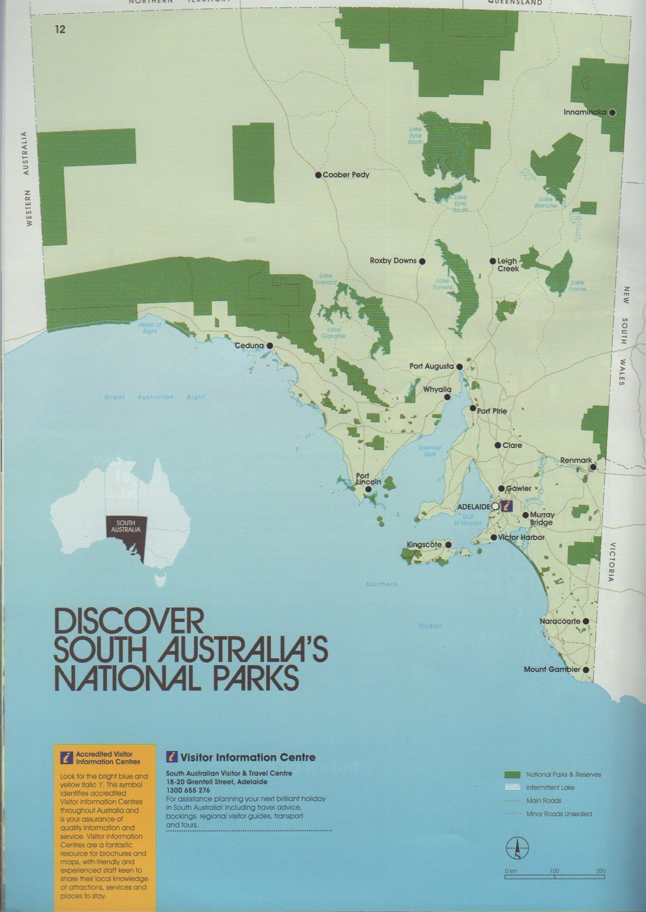

Appendix C

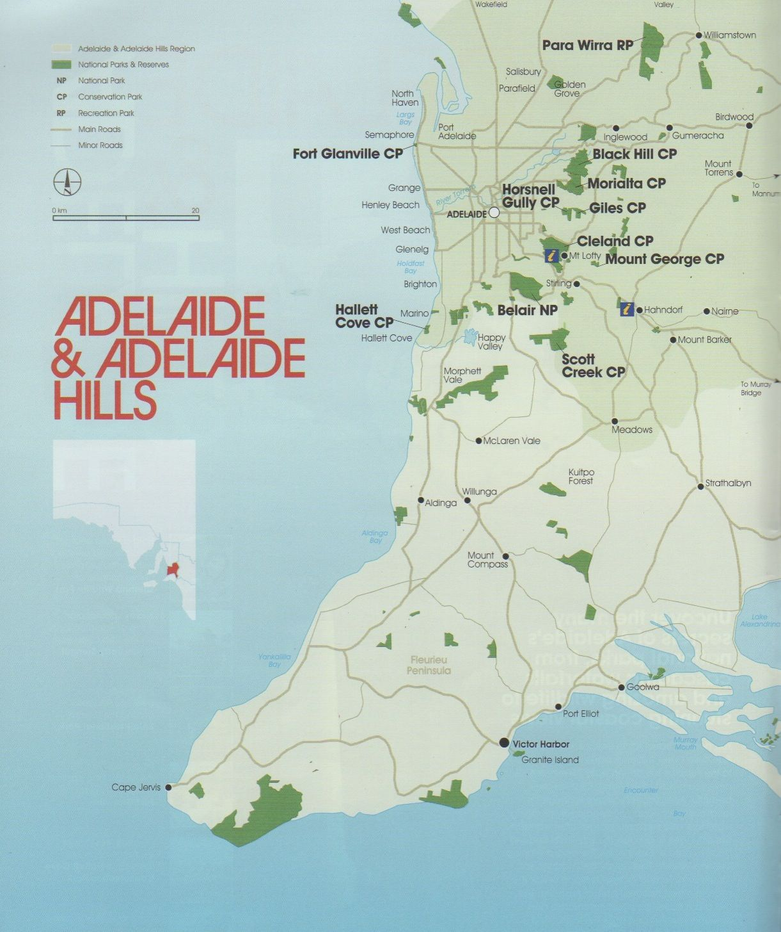

Appendix D

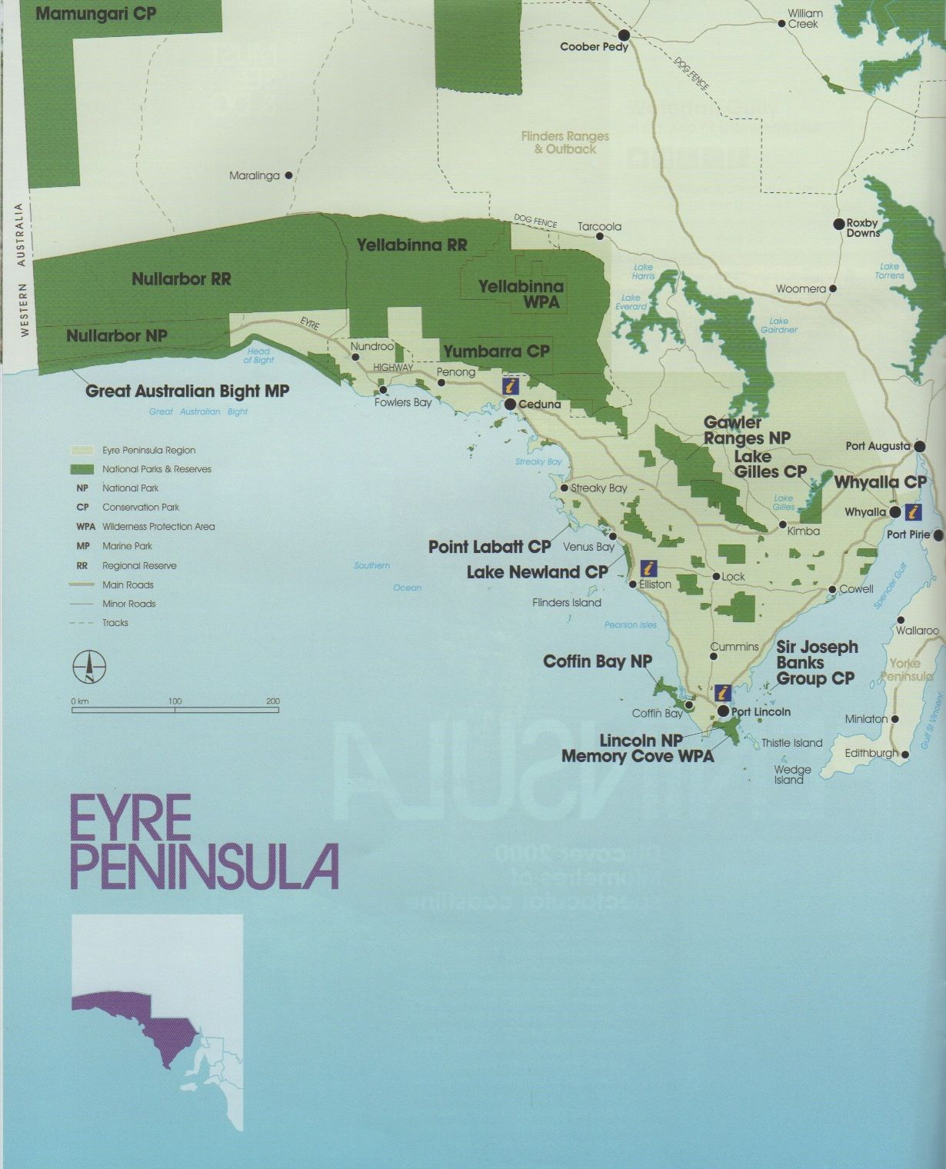
Appendix E

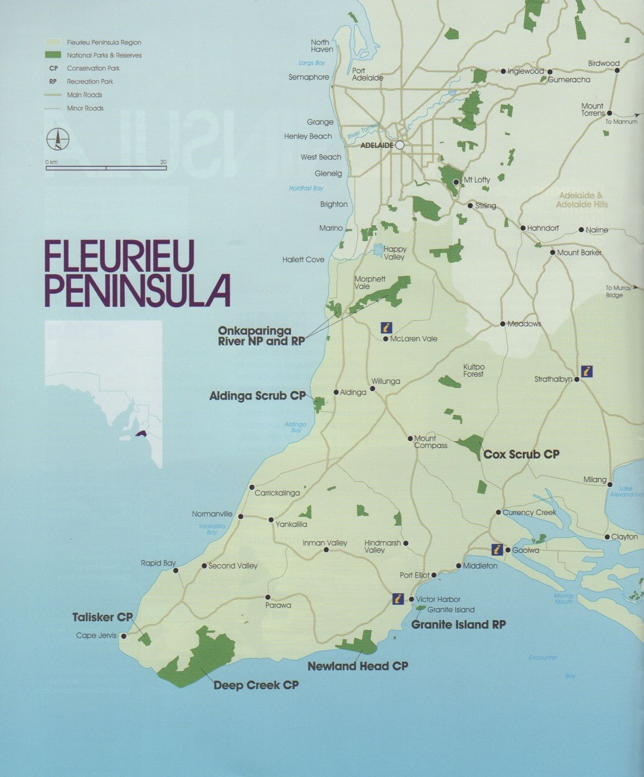

Appendix F

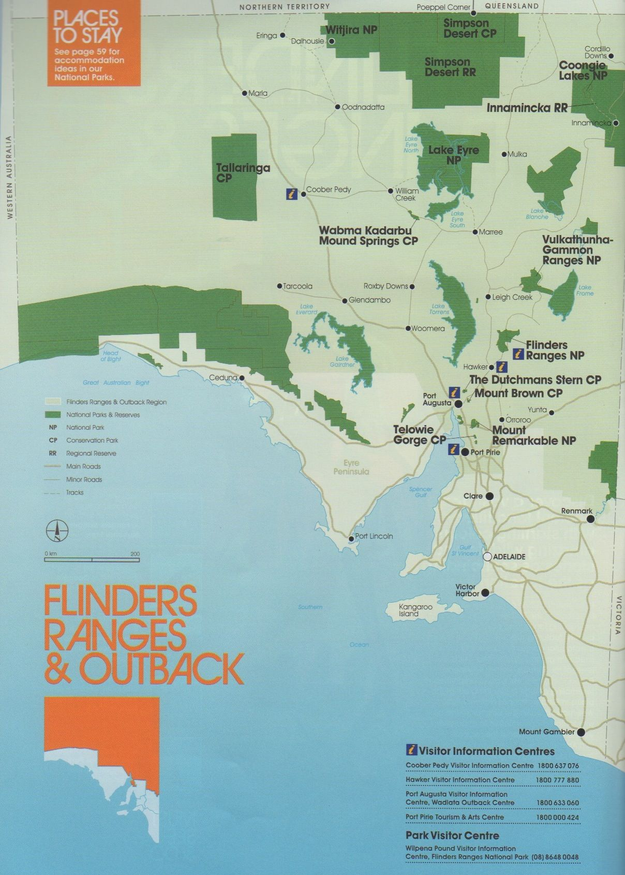

Appendix G

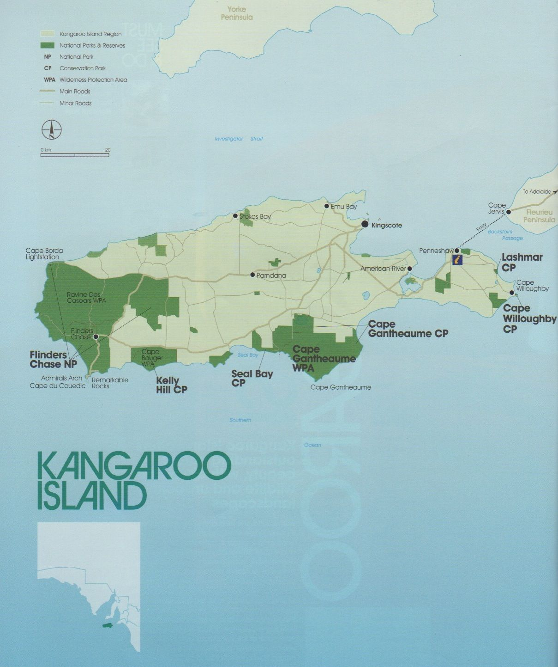

Appendix H

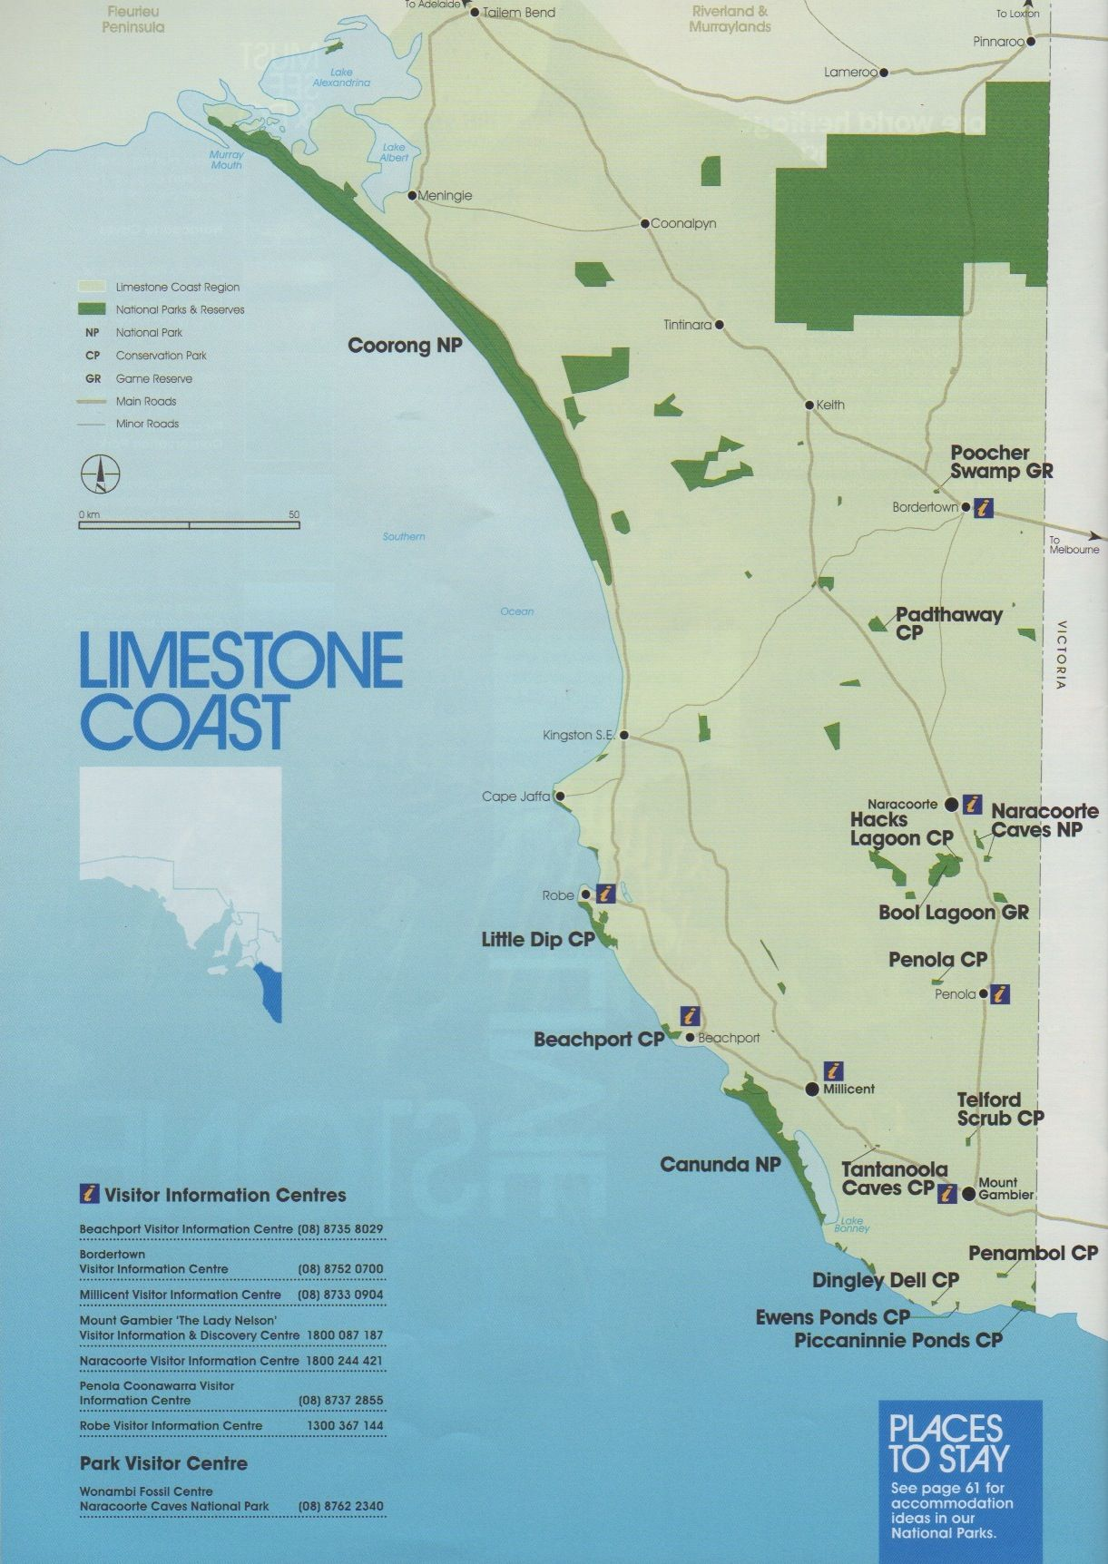
Appendix I

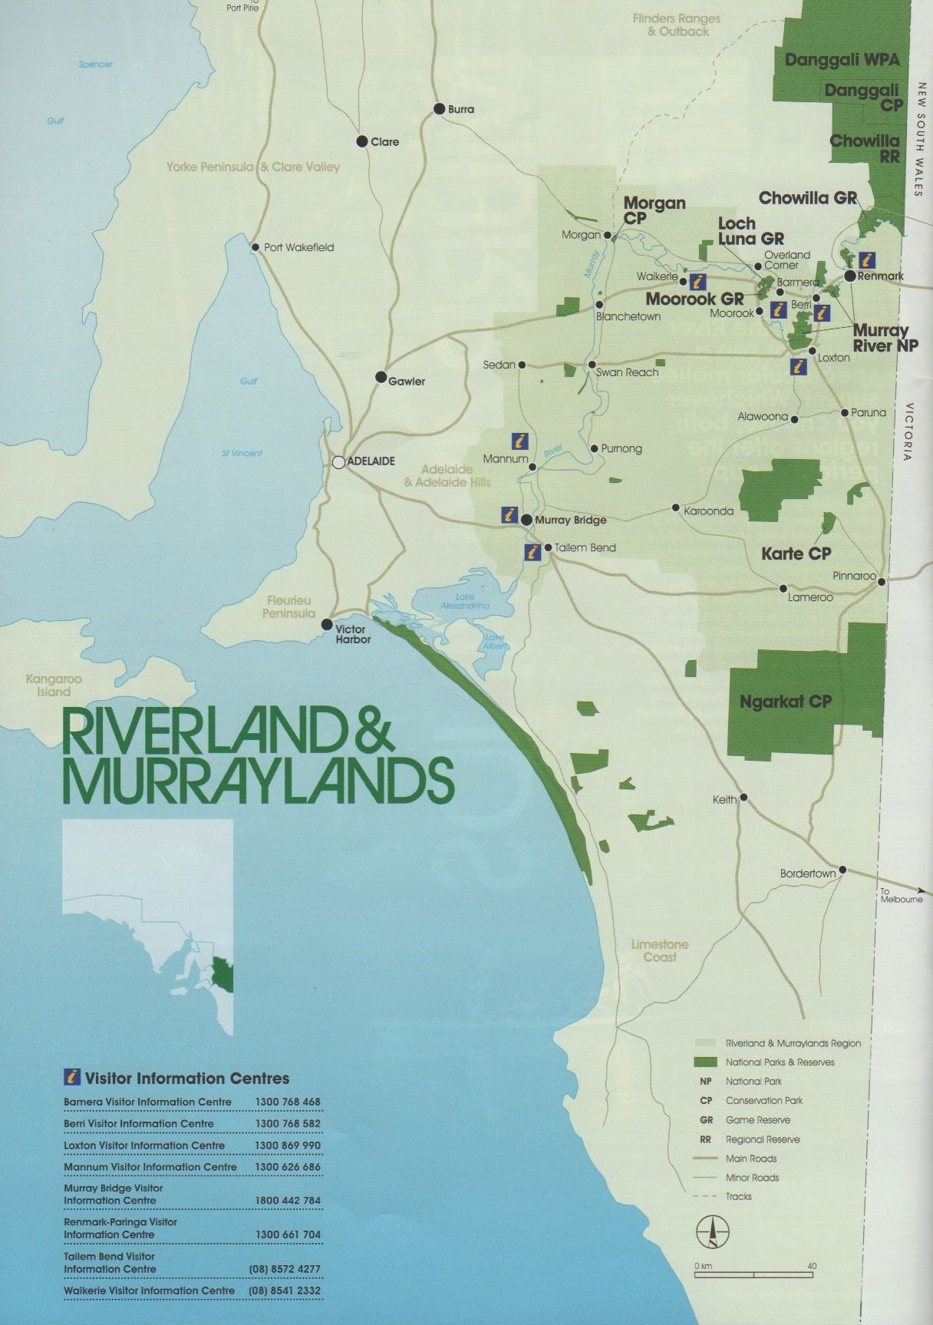
Appendix J

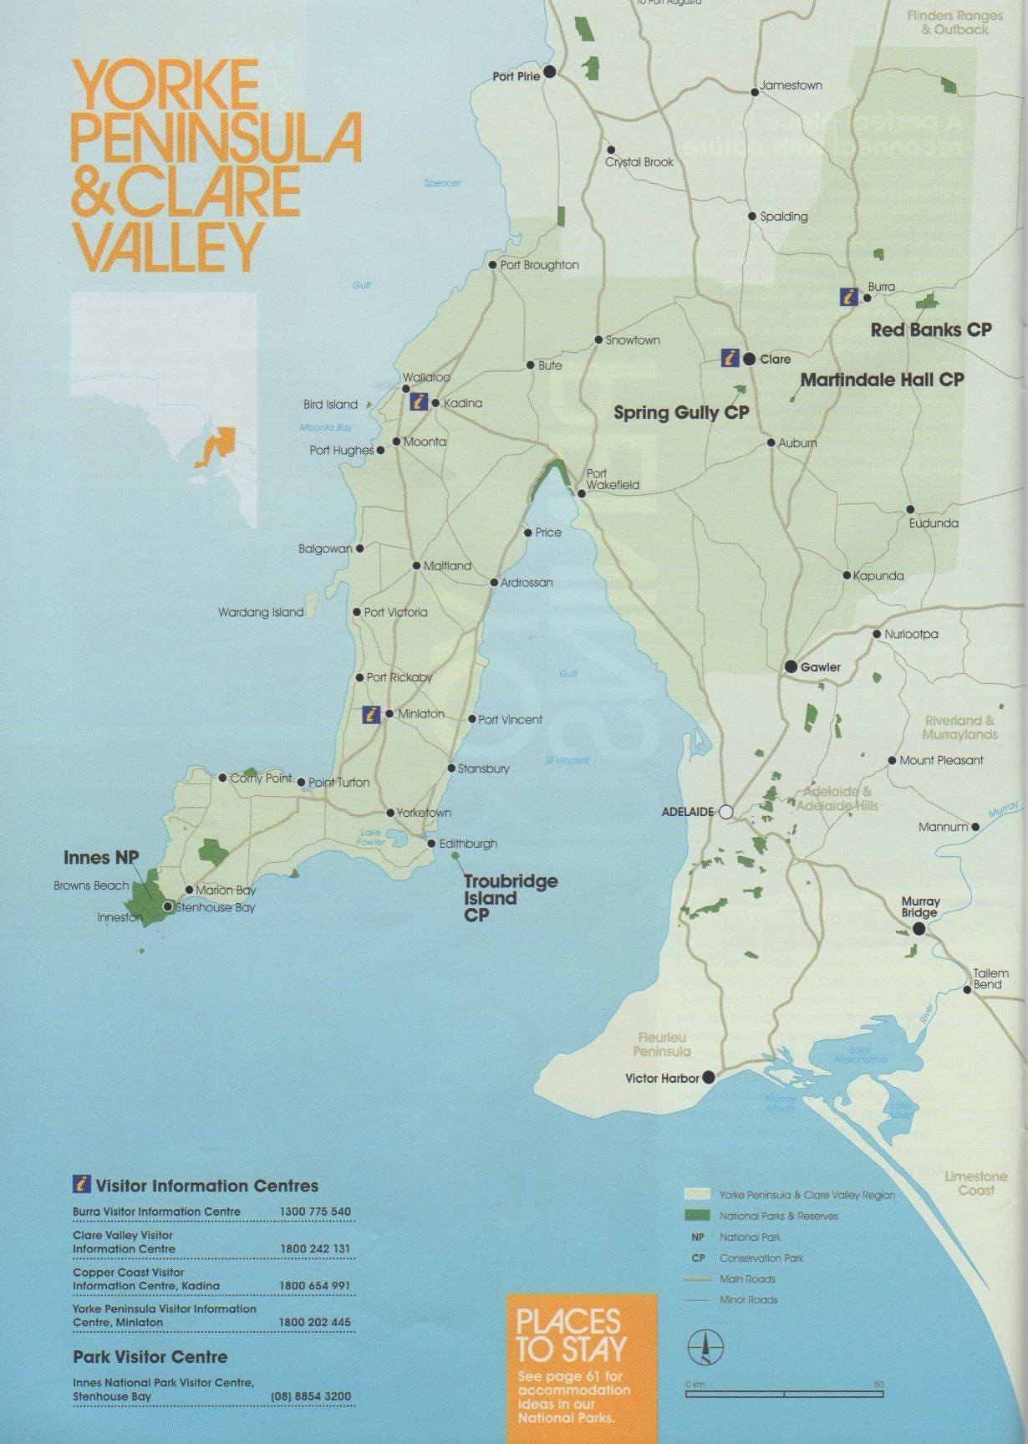

11. Misc. Notes

